Purchasing
Requisitions

How To Create an Inventory Pick Ticket EERP Version 2021.12

Objective
This document provides step-by-step instructions on how to requisition items from existing district inventory. This document is intended for experienced requisition users.

Overview
When you choose to create a pick ticket during the requisition process, you are actually requesting materials and/or supplies that are part of an inventory stored in a centralized area, such as a storeroom or warehouse.

Procedure
Use the following steps to create an inventory pick ticket:
- Open the Requisitions program Financials>Purchasing>Purchase Order Processing> Requisitions
- Click Add. 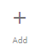
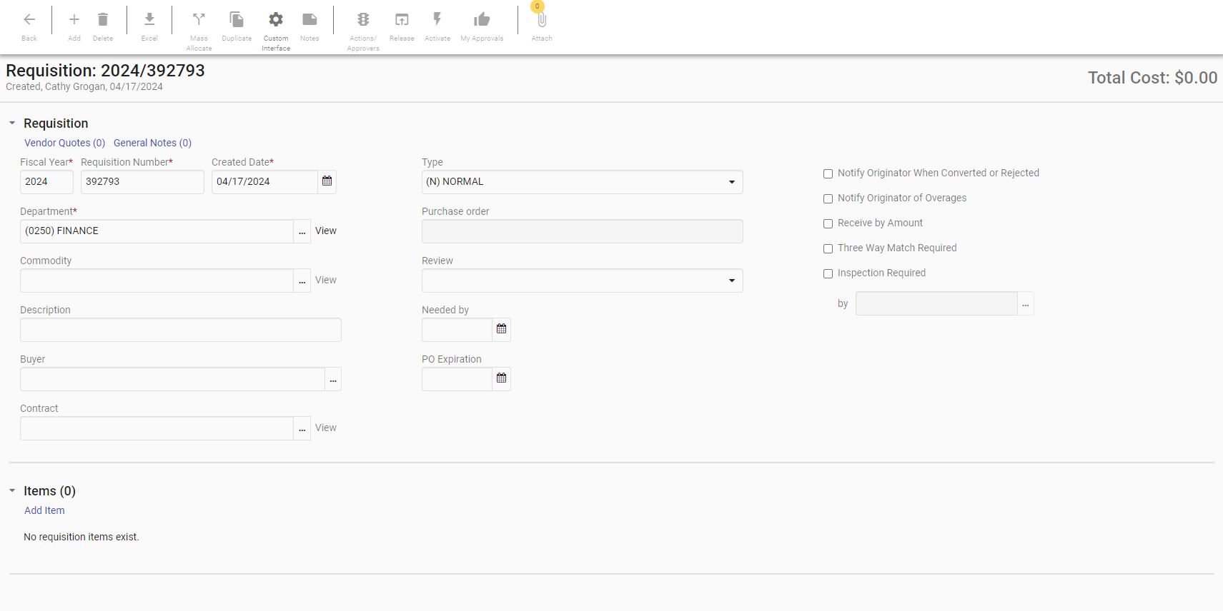

- If you have not applied the Custom Interface for Pick Tickets, do it now by selecting Custom Interface/Pick Ticket/Apply
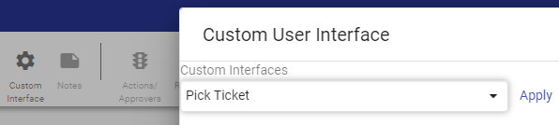
This will make your screen look like this:
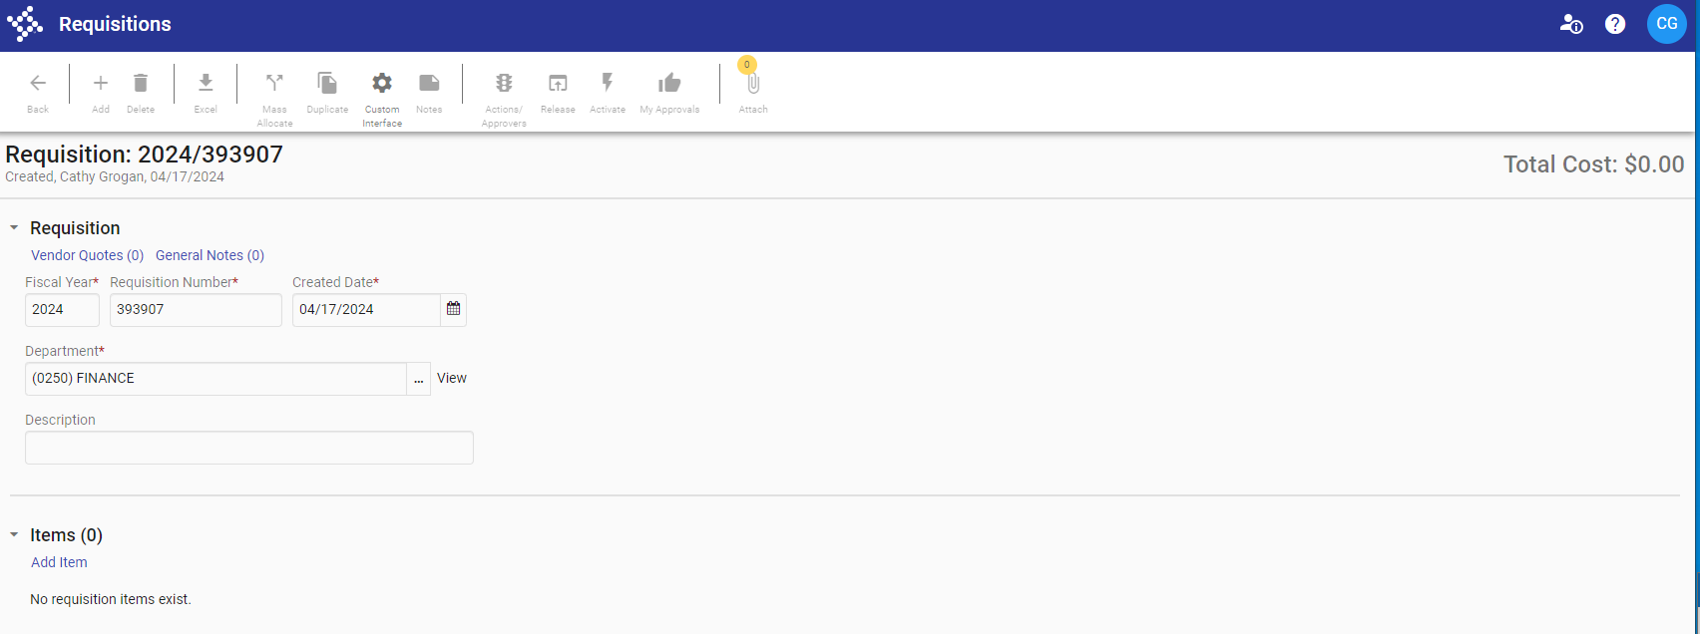
The interface will be applied until you remove it. You may toggle between this interface and the previous option of ‘None’ at any time.

- Enter the following information:
Fiscal Year | Will default to the current year
Dept/Loc | This will default to your department code. You may need to change this if you enter requisitions for multiple departments.
Requisition number | The system will auto-populate the field.
Description | Type in a description of the entire order. (for example ‘Custodial Supplies’ or ‘Copy Paper’)

- To add items to the Requisition, click on the Blue ‘Add Item’.

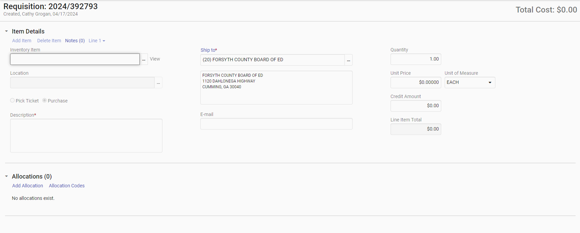
- Enter the following for the fields:
Inventory Item | Enter or select the code of the item being requisitioned. If you do not have the code you may start to type the name of the item and select from the list.
Quantity | The default value is 1. Accept the default value or enter another value.

- Once you have entered the Inventory Item, click on ‘Add Allocation’. You will see a prompt to ‘Add GL Account’. Click on this and add the appropriate Org/Object (and possibly Project).
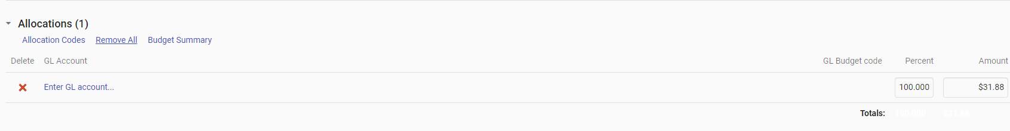

NOTE: When using inventory, the entire amount of each line item must be allocated to a single GL Account. Org may default based on the department code.
Example of ORG & Object # (XX represents your school number)
XX269990 561050
Once you have entered all information for this line item, click on ‘Save and Add Item’ in the bottom right of the screen to add additional items. Note that you can also delete a line after it has been entered. Click on ‘Delete Item’ in the top left of the screen if necessary. Click on ‘Save’ in the bottom right of the screen to complete the requisition.

Note that alternately it is possible to add all items and then Mass Allocate the Object/Org/Project IF all items are being charged to the same place. Simply save all items, and then click on ‘Mass Allocate’ at the top of your screen
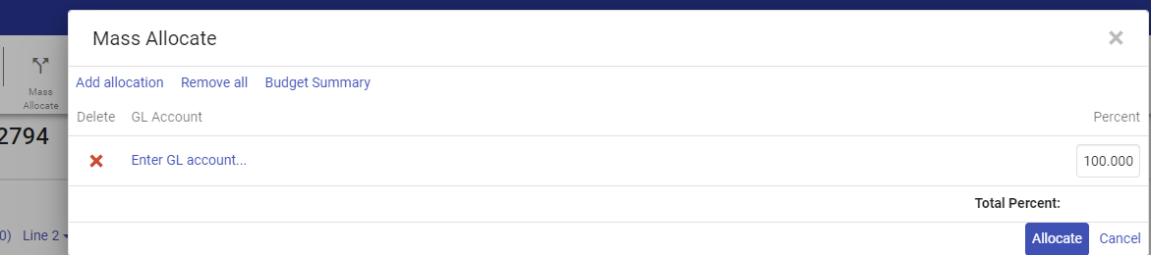

- To return to the Requisition Header screen, click Back 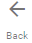.

- Once you have entered all requested items and returned to the Requisition Header screen, click Release in the Menu of the Ribbon. 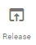 (Note that the status will update from allocated to released).

Results
The program starts the approval process for the requisition. Once a requisition has been released you can view it but cannot make changes to it. The principal will approve this, but you will not receive a PO for this. It will be sent directly to the warehouse and handled at the district.

Status Change
The status of a requisition changes depending on where it is in the process. The following are the status types for requisitions:
- A newly created requisition has a status of 2, which indicates that it is created.
- A requisition for which the line detail is complete has a status of 4, which indicates it is allocated.
- A requisition that has been released and/or approved has a status of 0, which indicates it is converted to a Purchase Order.

Note that to close out of the REQUISITIONS screen there is not a ‘back’ button. Once you are done on this screen simply close the tab in outlook for that screen.

